**PORTABLE LAUNCH SYSTEM FIELD GUIDE**

***BASE STATION SOFTWARE:***

In order to communicate with the ProXR Enhanced controller, run NCD Base Station software.

➢ Connect the device to your computer using the usb 802.15.4 port.

➢ Run the NCD Base Station software

➢ Select the appropriate COM port that says

➢ Click OK.

When the dialog box appears, select *‘ProXR Enhanced Relay Control Command Set’* by clicking once. Use the control panel to send commands to the device as illustrated on the following page.

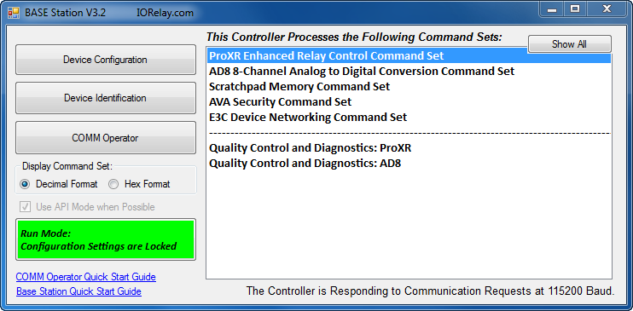

**Using software to control relays:**

A. Select where Relay Bank commands are directed to. Note: Selecting 0 directs commands to all available relay banks.

B. Simple On/Off control of individual relay in selected bank.

C. Set status of all relays in the selected relay bank.

D. Read the status of individual relays in selected bank.

E. Turn Off Automatic Refreshing, See page 9.

F. Communication Details. This portion of the interface is visible when selecting the MORE features is labeled section G in diagram.

G. Either reads MORE or LESS. MORE shows Section F in diagram. The LESS option shrinks the windows to exclude Section F.

H. This box is recommended to stay checked so commands are directed to banks correctly.

I. Set status of all relays in bank, see page 16.

J. Read status of all relays in selected bank, see page 13.

K. See Page 9

L. See Page 9

M. See page 9

N. Store current relay status as default power up status. See page 16.

O. Bring up window for controlling individual relay.

P. Test built in ProXR Timers.

Q. Group relays to be controlled simultaneously.

R. Opens a window with all Relay Flasher settings.

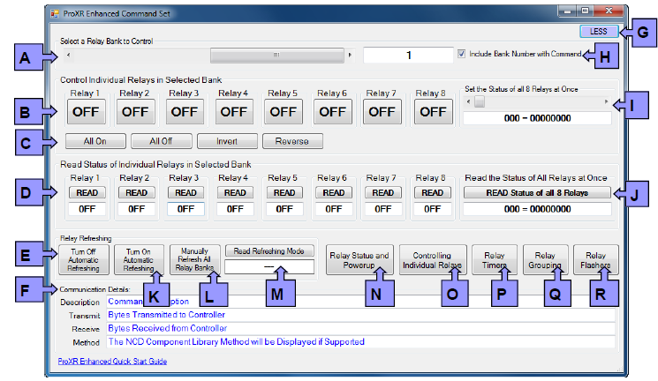

***A/D SOFTWARE:***

**Intro to AD8 series Controllers:**

AD8 Series controllers allow users to monitor sensors and switches. A/D inputs should never be left “floating,” which simply means all inputs MUST connect to something (such as a voltage or ground). To prevent inputs from floating, a 10K Resistor connects each input to +5 or Ground using the pull up/down jumper. While this 10K resistor does slightly interfere with the signal, its benefits far outweigh the consequences of leaving inputs floating.

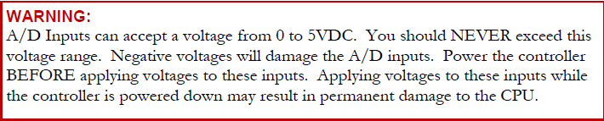

**Reading Switches/Variable Resistance Signals*:***

A/D inputs are ideal for reading the on/off status of switches. Simply position the Up/Down jumper in the UP Position and connect a switch between input and ground. Our software may then be used to monitor the contact closure status of your switch. AD inputs can also be used for reading variable resistance signals. Position of Up/Down jumper should also be in UP position for reading variable resistance signals. Controller will return 0-255.

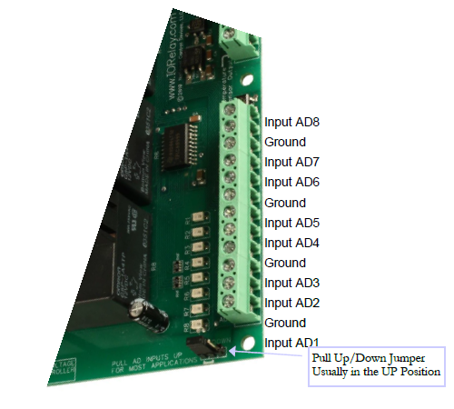

The AD8 Command Set is used to read analog voltages on controllers equipped with an 8-Channel 8/10-Bit Analog to Digital Converter. The AD8 Command Set converts a Voltage from 0 to 5 Volts DC into numeric values.

In order to communicate with the AD8 controller, run the NCD Base Station software.

➢ Connect the device to your computer using your favorite interface technology.

➢ Run the NCD Base Station software

➢ Select the appropriate COM port or IP Address

➢ Click OK.

*When the dialog box appears, choose ‘AD8 8-Channel Analog to Digital Conversion Command Set’ as shown in the screen shot below.*

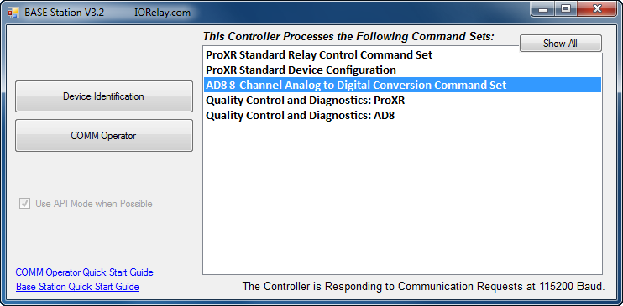

**AD8 GUI**

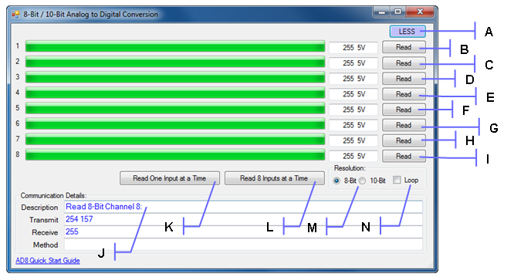

A. MORE or LESS. MORE option expands windows to include section I of diagram. LESS option shrinks window to exclude section I.

B. Read Analog Input Channel 1

C. Read Analog Input Channel 2

D. Read Analog Input Channel 3

E. Read Analog Input Channel 4

F. Read Analog Input Channel 5

G. Read Analog Input Channel 6

H. Read Analog Input Channel 7

I. Read Analog Input Channel 8

J. Communication Details. This section is shown when the MORE option from section A of the diagram is selected.

K. This button queries all A/D Inputs, each one individually (8 Individual Commands).

L. This button queries all A/D Inputs using a single command, which is much faster.

M. 8-Bit Resolution means each input will return a value from 0 to 255 One Communication Byte is received from the device for each channel using 8-Bit Resolution 10-Bit Resolution means each input will return a value from 0 to 1023. Two Communication Bytes are received from the device for each channel using 10-Bit Resolution.

N. The Loop Option will query constantly until the Loop options are unchecked.

**Alternate A/D Program**

The creators of the NCD Base Station software have created a fully functioning library of “sample” codes that expand on their pre-loaded programs. The A/D Sample 5 program will read the A/D ports at a user defined sample rate and transform the bit values to a voltage unlike the pre-loaded version. It can be downloaded from the NCD component Library on the Relay Pros website.

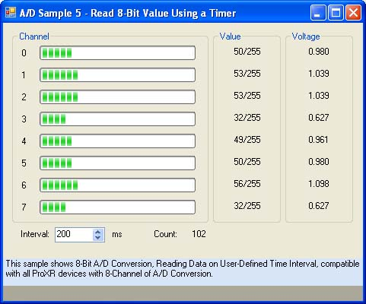

***Troubleshooting***

**Troubleshooting Relay Control**

Use the Base Station Software to diagnose any problems with your device. Choose the option **‘ProXR Quality Control and Diagnostics’** as shown below.



***Steps:***

A. Set number of relays to test.

B. Start Relay test sequence.

C. Select individual bank to test.

D. Set relay test sequence speed.

E. Test functionality of PGM/RUN jumper. To Pass move jumper to PGM position, then to RUN position.

F. Used as a reminder to testing staff to check functionality of all on board LEDs, click to “Pass”.

G. Used by testing staff to check continuity of relays. Click to “Pass”.

H. Used by testing staff to check XR Expansion Port. Click to “Pass”.

I. Used by testing staff to check 3.3 vdc circuit voltage. Click to “Pass”.

J. Used by testing staff to check 5 vdc circuit voltage. Click to “Pass”.

K. Pause testing sequence.

L. Reset all status boxes.

M. Used by testing staff for continuity outputs.

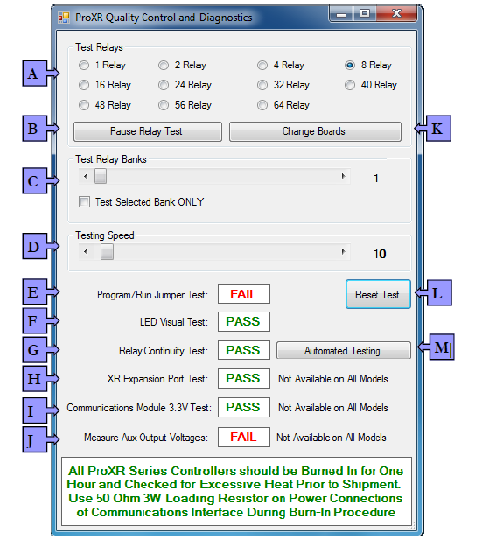

**Troubleshooting A/D ports**

Use the ‘AD8 Quality Control and Diagnostics’ to help identify problems with the controller.

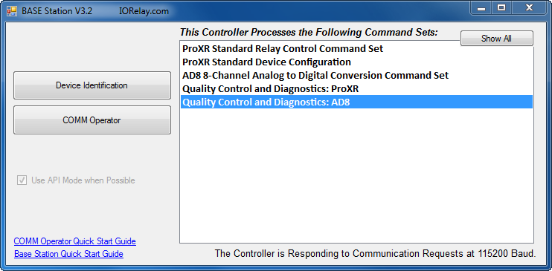

The testing procedure for AD8 Series devices tests the Up/Down Jumper and all 8 inputs.

To “PASS” input Channels 1 through 8, make sure the Up/Down Jumper is in the UP Position, and connect each input individually to ground. As the input goes low, the FAIL will turn to PASS.

